**Not quite insects!! Springtails or Collembola**.

The name Collembola, derived from the Greek "coll" meaning glue and "embol" meaning a wedge, refers to a peg-shaped structure, the collophore, on the underside of the first abdominal segment.  The collophore was once thought to function as an adhesive organ, now is thought to play a role in osmoregulation. These were once considered insects, now placed in a separate group under the Hexapoda, a group that also contains the insects. They are also known as springtails because of their forked jumping organ (the **furcula**) found on the fourth abdominal segment.

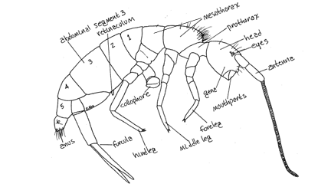

Everyone should examine the springtails because they are so common and one of the most numerous arthropods found in any sample containing moss. Observe springtail movement. How do they use their legs as opposed to the furcula? Obtain a video of their movements if possible.

They do share some attributes of insects, with a body divided into three parts, consisting of a head with antennae, a three-segmented thorax, each segment having a pair of jointed legs, and an abdomen. Their mouthparts are hidden. So they are hexapods, but not insects that sport visible mouthparts. Obtain as best a photograph as you can of the mouthparts, so you can compare it to your photograph of termite mouthparts.

**Termites are true insects.**

They are social and many species have castes, or individuals that differ in morphology and their role in termite society. You should have some workers and perhaps a soldier (larger, larger head and jaws) in your petri dish. Take a photograph of your termite and label as many body parts as you can.

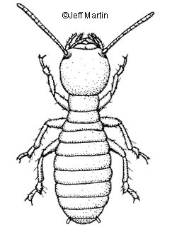 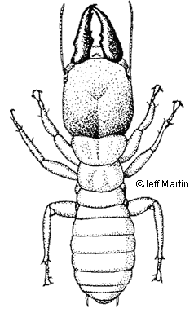

Try to obtain a photograph of the mouthparts, which is partially what distinguishes them as true insects, but do not open the petri dishes. These guys are great escape artists. You will not have to label the photograph, but it will serve to document your efforts.